Topological materials from an STM perspective: Studying pristine
and magnetically doped surfaces in real and reciprocal space
Matthias Bode
Lehrstuhl für Experimentelle Physik II, Universität Würzburg
Recently topological insulators (TIs), a material class that is insulating in the bulk but conducting on the surface, have attracted considerable interest. TIs host linearly dispersing surface states that are strongly spin-orbit coupled such that spin and electron momentum are tightly locked, thereby suppressing backscattering. Since this electronic structure results in charge currents which are intrinsically tied to the spin, TIs are, for example, considered as potential candidates for spintronics applications.
In this talk I will discuss how the electronic properties of topological insulator surfaces can be studied by scanning tunneling microscopy (STM)-based techniques. Our results revealed how the electronic structure of pristine TIs changes as magnetic adatoms are deposited on the surface and when magnetic order sets in. In particular, I will discuss various electronic scattering channels, which are mapped with the scanning tunneling microscope by the so-called quasiparticle interference method. In combination with local tunneling spectroscopy it allows for an extremely precise understanding of how topological states respond to magnetic impurities at the atomic scale. The combination of real and reciprocal space techniques elucidates a delicate balance between two opposite trends, that is, gap opening and the emergence of a Dirac node impurity bands, both induced by the magnetic dopants.
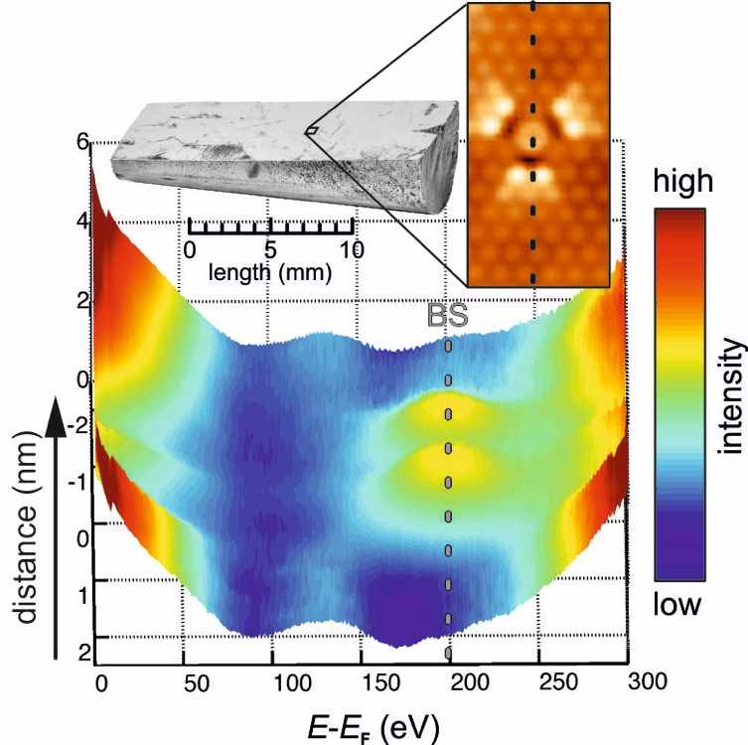

Photographic (top left) and STM image (right) taken around a V impurity in Sb₂Te₃ crystal. Bottom panel: spectroscopic measurements taken along line. A strong resonances close to the Dirac point emerges.

